**ARIMA and SARIMA**

In time series (TS) problem, unlike areas such as computer vision or natural language processing where deep learning (DL) techniques are now well entrenched, there still exists evidence that ML and DL struggle to outperform classical statistical TS forecasting approaches. So the classical approaches have demonstrated a good performance in this filed. Methods like ARIMA and SARIMA.

The ARIMA model acronym stands for “Auto-Regressive Integrated Moving Average” and for this article we will break it down into AR, I, and MA. Also, in SARIMA the “S” stands for seasonality. Here firstly each part will be investigated and then the general formula will be reviewed.

**i) Autoregressive Component - AR(p)**

The autoregressive component of the SARIMA model is represented by AR(p), with the p parameter determining the number of lagged series that we use. Actually by this term the model uses the dependent relationship between an observation and some number of lagged observations.

**ii) Integrated- I(d)**

The use of differencing of raw observations in order to make the time series stationary.

**iii) Moving Average - MA(q)**

By this term, the model uses the dependency between an observation and a residual error from a moving average model applied to lagged observations.

**iv) Seasonality - S(P,D,Q,s)**

If we have a periodic pattern like weekly or monthly trends in our data, we will use seasonality.

The general formula of SARIMA is as follow.

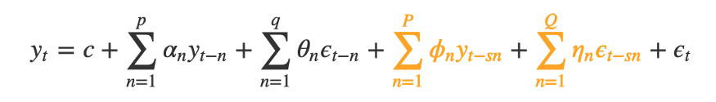

Where the $α$, $θ$, $ϕ$, and $η$ are the model’s parameters that calculate during fitting process and p, d, q, P, D, and Q are it’s hyperparameters that should be determined before starting learning. PAI as an Automated AI solution in addition to find the best value of model’s parameters, investigates the best hyperparameters with hyperparameter optimization algorithm and you don’t need to set them manually and just enough to import your data and enjoy forecasting.